NB – Please Read – Important Information Regarding your Cartridge

Canon cartridges empty or low Ink error
This is an unavoidable downside of using refilled or remanufactured cartridges in your Canon machine.
This error occurs due to the chip on your cartridge still reporting a low or empty ink level from it’s previous use. The chip itself cannot be reset, so when the cartridge is refilled and then installed into a new machine it will still register as empty.
The following fix will work with nearly any refilled Canon cartridges, including the popular ranges:
- PG-40 & CL-41
OUR NEW WEBSTORE
NOW OPEN
- PG-50 & CL-51
- PG-540 & CL-541
- PG-545 & CL-546
- PG-510 & CL-511
- PG-512 & Cl-513
- PG-560 & CL-561

How to stop your printer reporting low ink
To disable the status monitor in your Canon printer, hold the printer’s stop/reset button for 5 seconds only when the Cartridge says its Empty (This is a false warning as we cannot reset the electrics on the Cartridge but holding down the reset button WILL override the warning and the printer will print from now on).
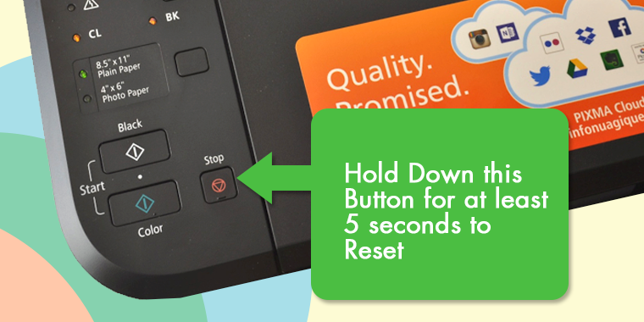
Once this is done you will no longer get updates about your ink levels. While this isn’t ideal, it means you can still enjoy the cost savings from the refilled or remanufactured Canon cartridges, without pesky alerts.
Make sure you monitor the print quality from these cartridges. Once they start to fade, the ink is likely running low and they will need replacing. Finally, ignore any “Print Quality” alerts the printer gives you. It’s an automatic response from you installing a used cartridge, and they will work fine until they run out of ink.

