Instructions for Cleaning Epson Printheads.

It is important to perform this procedure each time a cartridge is changed in your printer. Performing the head clean once, maybe twice is usually sufficient to return your print quality to what it should be.

If this is having no effect, be aware that it is possible the printheads have dried up too much and may need professional attention.

To clean printheads;

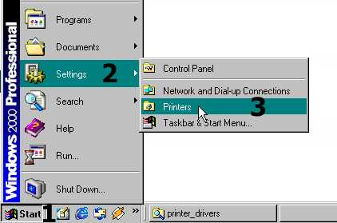
Most operating systems and Epson printer utilities will look similar to this example, so if any pictures vary slightly in appearance do not worry, the end result will be the same.

Start by clicking on the ‘START’ button on the bottom left of your main window. (1), then move your cursor to ‘settings’ (2) and then to ‘printers’ (3). On some operating systems like XP you do not need step (2) as a box saying ‘printers and faxes’ will appear. Click on this (left mouse button) with your cursor over it.

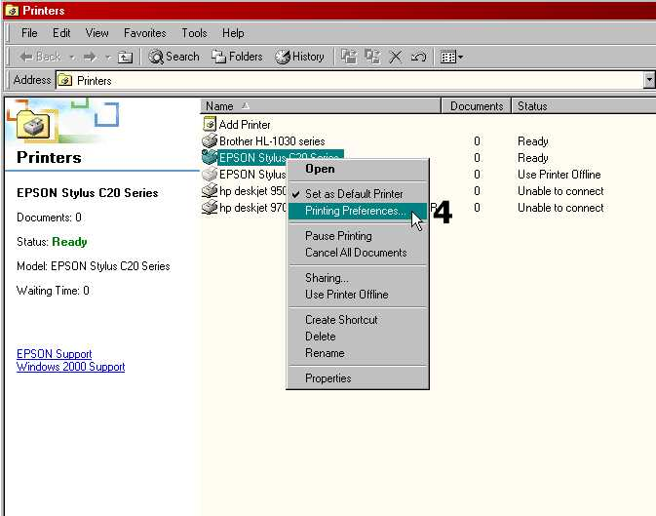
This will open up a window showing installed printers in a list (or as icons if set up that way). Move your cursor over your printer icon or name (4) and press your left mouse button, revealing the list below. Choose ‘printing preferences..’This will open your printer options as shown below. Each printer has a slightly different look, but all have the tabs at the top, one of which says ‘utilities’. Move your cursor over this tab (5) and press your left mouse button.
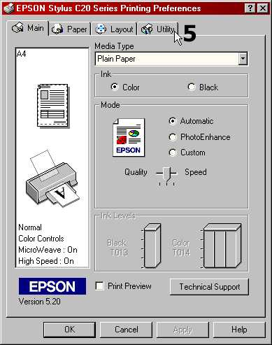

This opens the Window you want. Use your mouse cursor to left click on the ‘Head Cleaning’ icon (6) and follow the instructions.
